STREAMLINING IT PROCUREMENT
Automating Standard Laptop Orders with Flow Designer
ServiceNow Project Documentation

Team ID | SWTID-2026-2597
Team Size | 5
Team Leader | SANTHIYA M
Team Member | SRIDHARSHINI T
Team Member | SARAL NILA M
Team Member | ROSHINI R / RITHIKA S

1. Project Overview

Problem Statement
The current IT procurement process lacks efficiency and automation, resulting in delays and manual overhead, particularly in handling standard laptop orders. Requests for standard laptops often require configuration, but this step is prone to oversight or delay, leading to frustration among users and inefficient resource allocation within the IT department.

User Story
As a member of the IT procurement team, I want a streamlined process for ordering standard laptops so that tasks are automatically generated and assigned to the Hardware team for configuration. This will ensure that laptops are promptly configured upon arrival, reducing user wait times and minimizing manual intervention.

Project Objectives
- Create a seamless experience for users requesting standard laptops by ensuring timely configuration.
- Reduce manual intervention and potential errors in the procurement process.
- Improve resource utilization within the IT department by optimizing task allocation.
- Enhance overall efficiency and productivity in IT procurement operations.

2. Task Initiation

Milestone 1: Flow

Activity 1: Create a Flow to Create a Catalog Task
Create a ServiceNow Flow Designer flow that creates a Catalog Task for a Standard Laptop request. The task is configured for the Hardware assignment group and is created when the Service Catalog trigger conditions are met.

Step 1 – Open Flow Designer
- Open ServiceNow.
- Click All and search for Flow Designer.
- Open Flow Designer under Process Automation.
- Click New and select Flow.
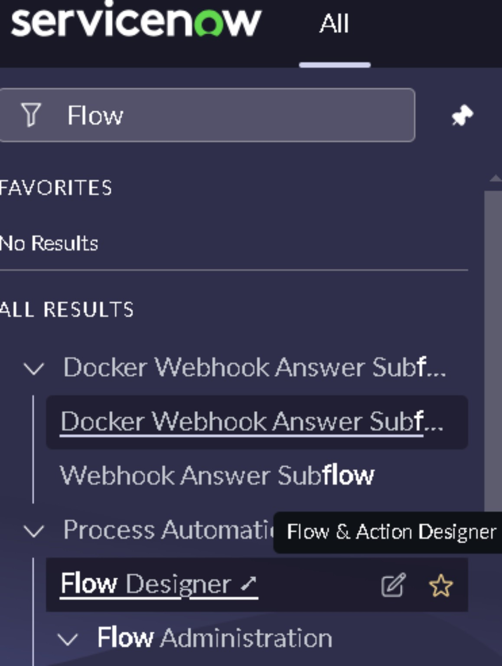
Figure 1. Searching for Flow Designer in ServiceNow.
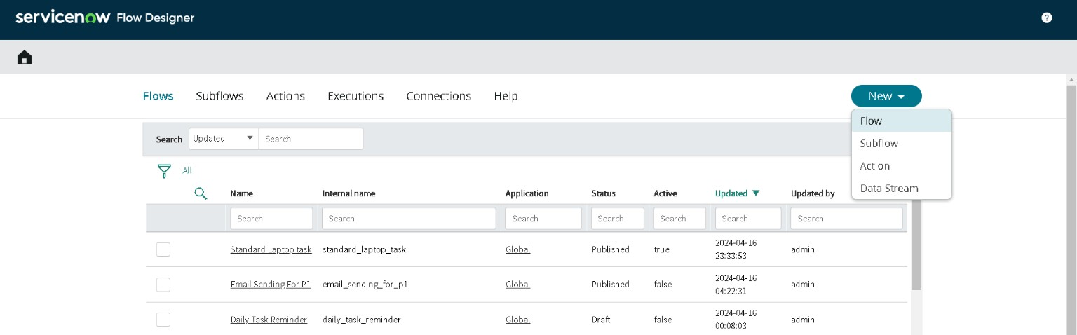
Figure 2. Flow Designer – New > Flow.

Step 2 – Configure Flow Properties
Under Flow properties, configure the flow with the following values:
- Flow name: Standard laptop task
- Application: Global
- Run As: System User
- Click Submit.
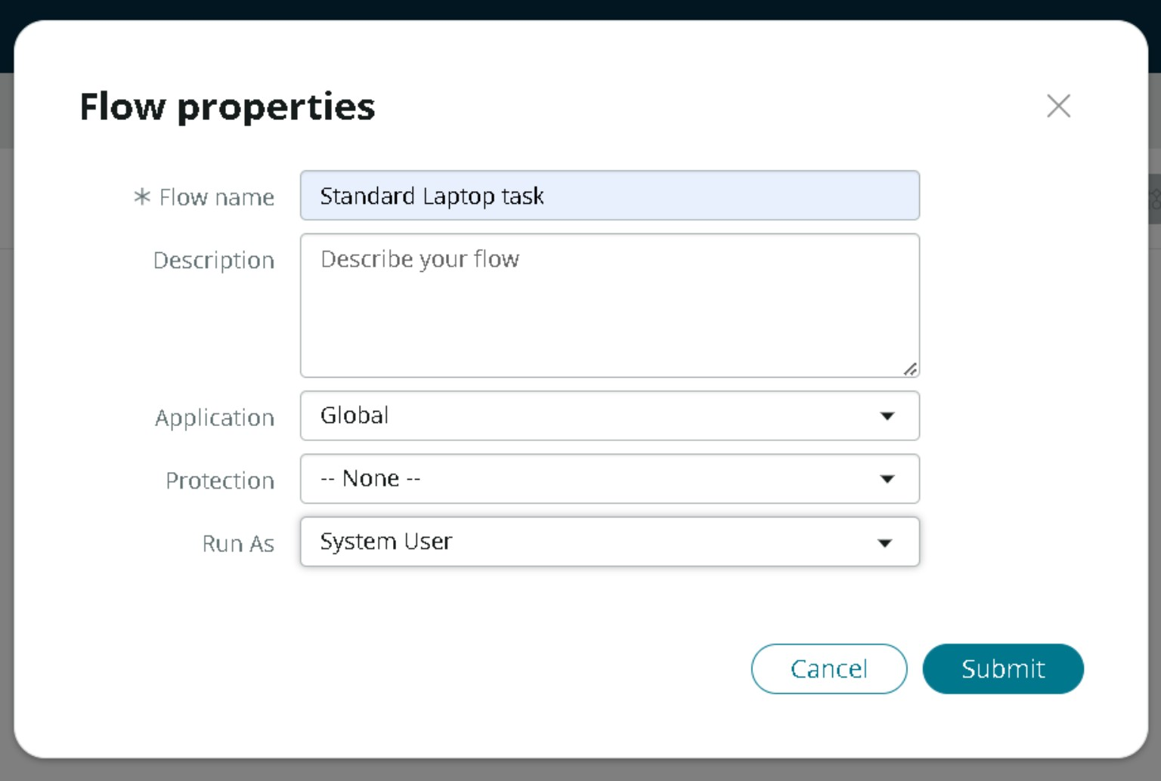
Figure 3. Flow properties for the Standard laptop task.

Step 3 – Add the Trigger
- Click Add a Trigger.
- Search for Service Catalog in the trigger list.
- Select Service Catalog.
- Click Done.
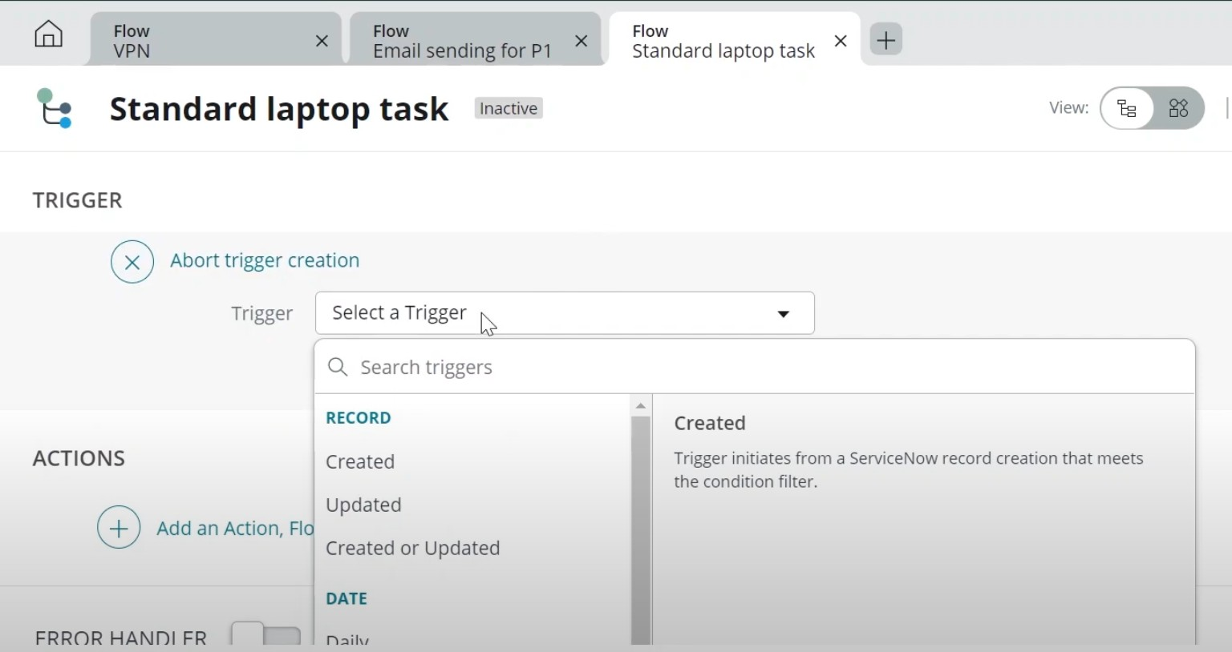
Figure 4. Selecting a trigger in Flow Designer.
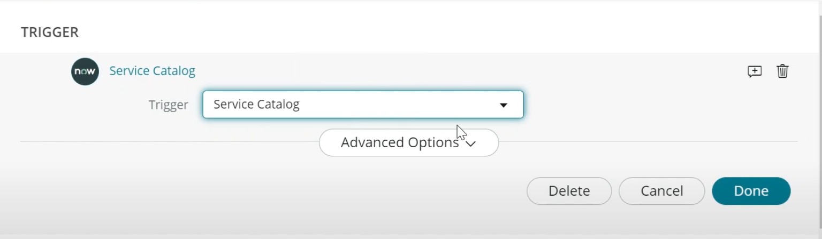
Figure 5. Service Catalog trigger selected.

Step 4 – Add the Create Catalog Task Action
- Under Actions, click Add an Action.
- Search for Create Catalog Task.
- Select the Create Catalog Task action.
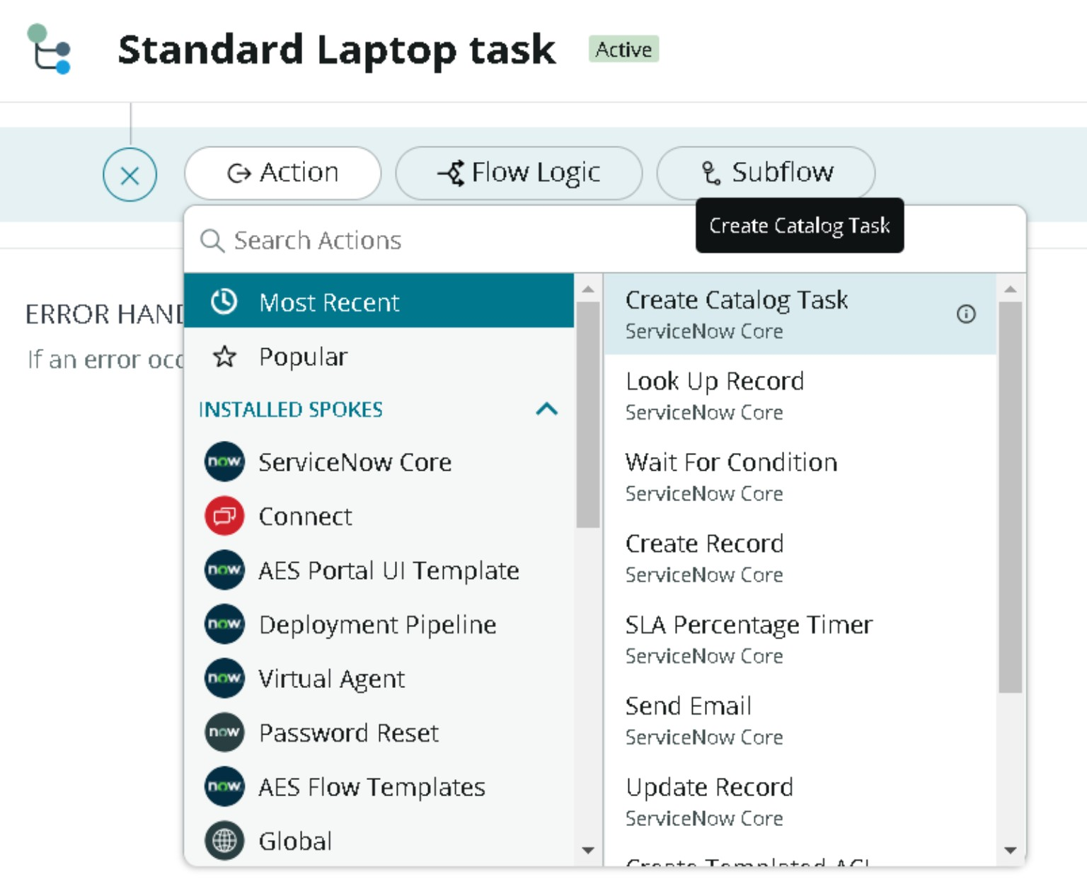
Figure 6. Selecting the Create Catalog Task action.

Step 5 – Configure the Catalog Task
Configure the action using the following values:
Field | Value
Action | Create Catalog Task
Requested Item | Drag and drop the Requested Item Record from the Service Catalog trigger
Table | Catalog Task [sc_task] (auto-populated)
Short Description | Laptop needs to Configured
Description | Laptop needs to Configured
Assignment group | Hardware
Approval | Approved

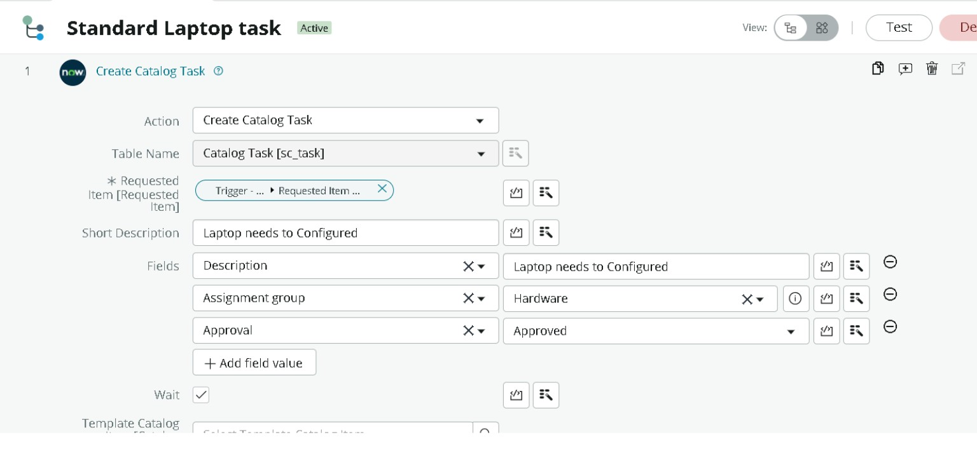
Figure 7. Create Catalog Task action configuration.

Step 6 – Save and Activate the Flow
- Leave the remaining options at their default values.
- Click Done.
- Save the flow.
- Click Activate and confirm by clicking Activate again.
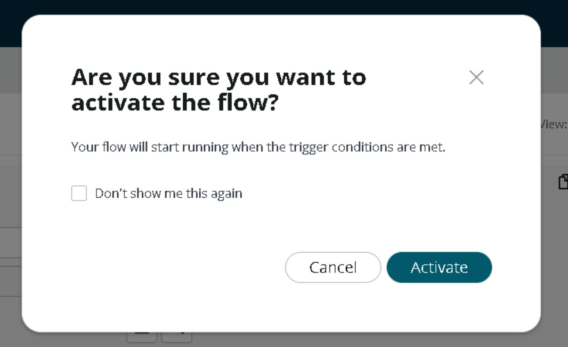
Figure 8. Flow activation confirmation.

3. Milestone 2: Flow Assignment

Activity 1: Assign the Flow to the Standard Laptop Catalog Item
The Standard Laptop catalog item must use the newly created Flow instead of the other process engines. This ensures that requests for the Standard Laptop item use the automated Flow.

Step 1 – Open Maintain Items
- Open ServiceNow.
- Click All and search for Maintain Items.
- Select Maintain Items.
- Search the Name field for Standard Laptop and open the record.
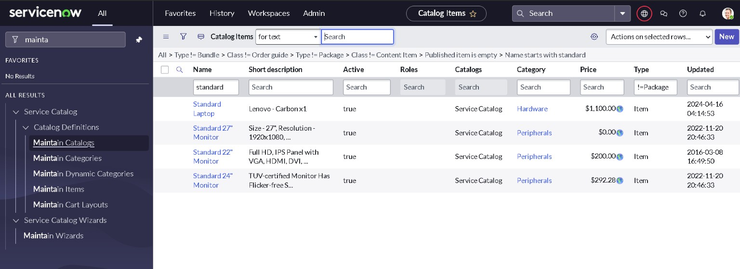
Figure 9. Maintain Items – locating the Standard Laptop catalog item.

Step 2 – Configure the Process Engine
- Open the Process Engine section of the Standard Laptop catalog item.
- Remove any remaining process automation that should not be used for this item.
- Select Flow as the process engine.
- Select the flow named Standard laptop task.
- Save/Update the catalog item.
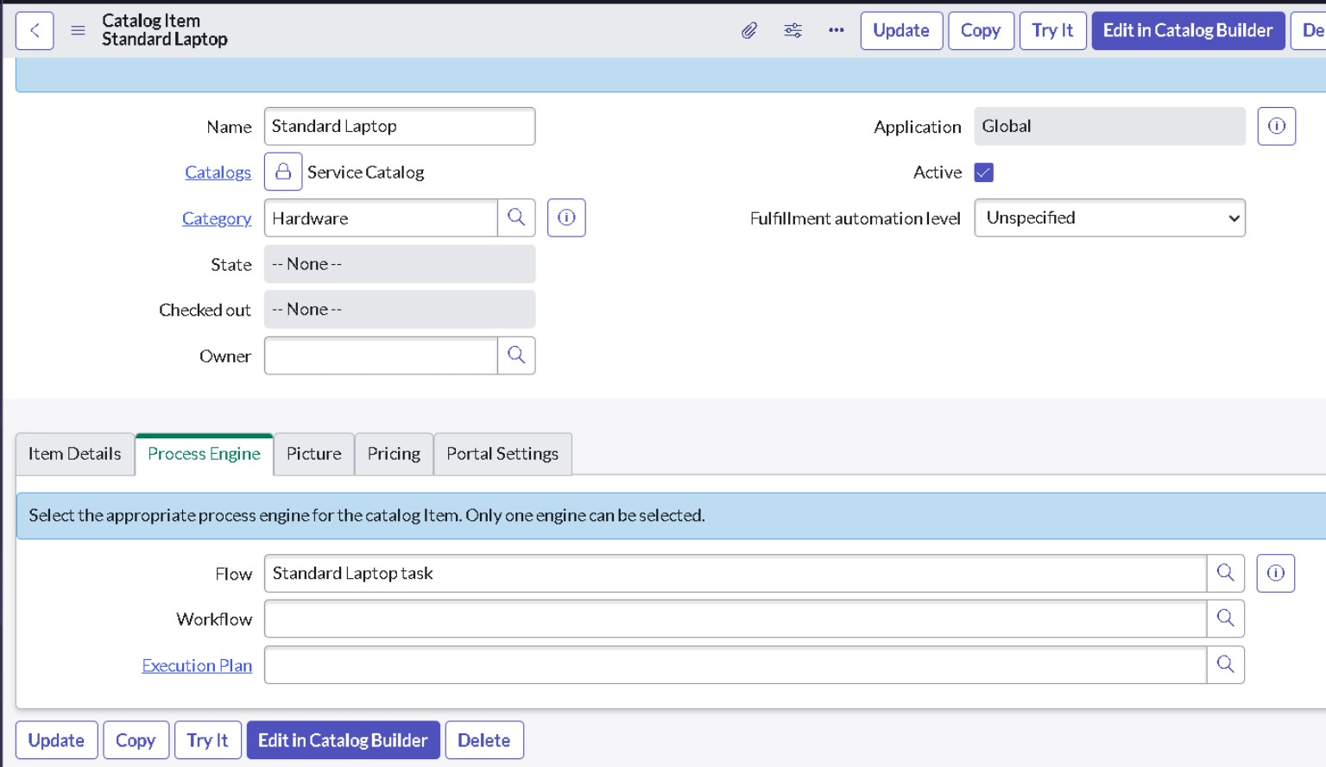
Figure 10. Standard Laptop catalog item – Process Engine configured with the Flow.

Milestone 2 Outcome
The Standard Laptop catalog item is now associated with the Standard laptop task Flow. When the configured Service Catalog process runs, the Flow can create the required Catalog Task for the Hardware team with the specified description and approval status.
4. TASK 3 – SERVICE CATALOG
Milestone 3: Service Catalog
Activity 1: Place a Standard Laptop Order and Get Approvall
The Standard Laptop catalog item is used to place a service request through the Service Catalog. After submitting the request, the approval status and Requested Item record are verified. The associated Catalog Task is then checked to confirm that the Flow Designer automation has successfully created and assigned the task to the Hardware team.
Step 1 – Open Service Catalog
- Open ServiceNow.
- Click All.
- Search for Service Catalog.
- Open Service Catalog.
- Click the Hardware category.
- Scroll through the available hardware items.
- Locate Standard Laptop.
- Click Standard Laptop.
- Review the Standard Laptop catalog item.
- Click Order Now to place the request.
- After submitting the order, the system displays the Order Status.

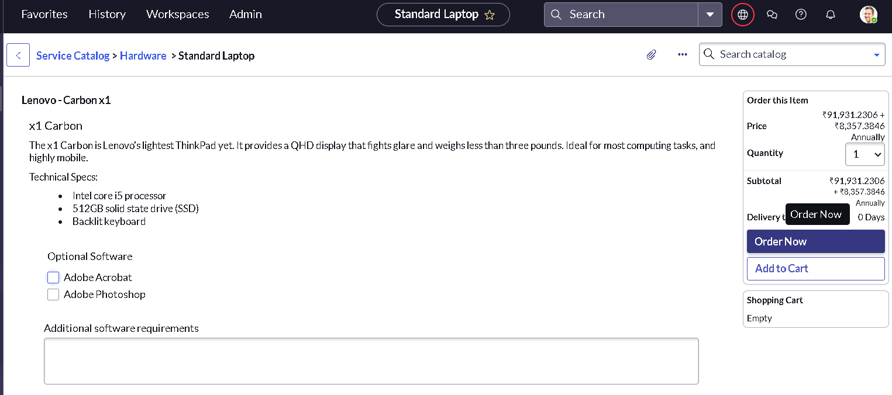

Figure 12. Standard Laptop catalog item – Order Now

Step 2– Open the Request Record
12.Review the Order Status page.
13.Locate the generated Request Number.
14.Click the Request Number.
15.The Request Number record will open.
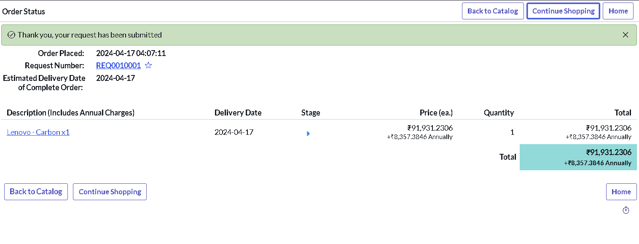

Step 3 – Verify and Approve the Request
16.In the Request record, scroll down to the Approvers section.
17.Locate the approval record.
18.Right-click the record to view the available actions.
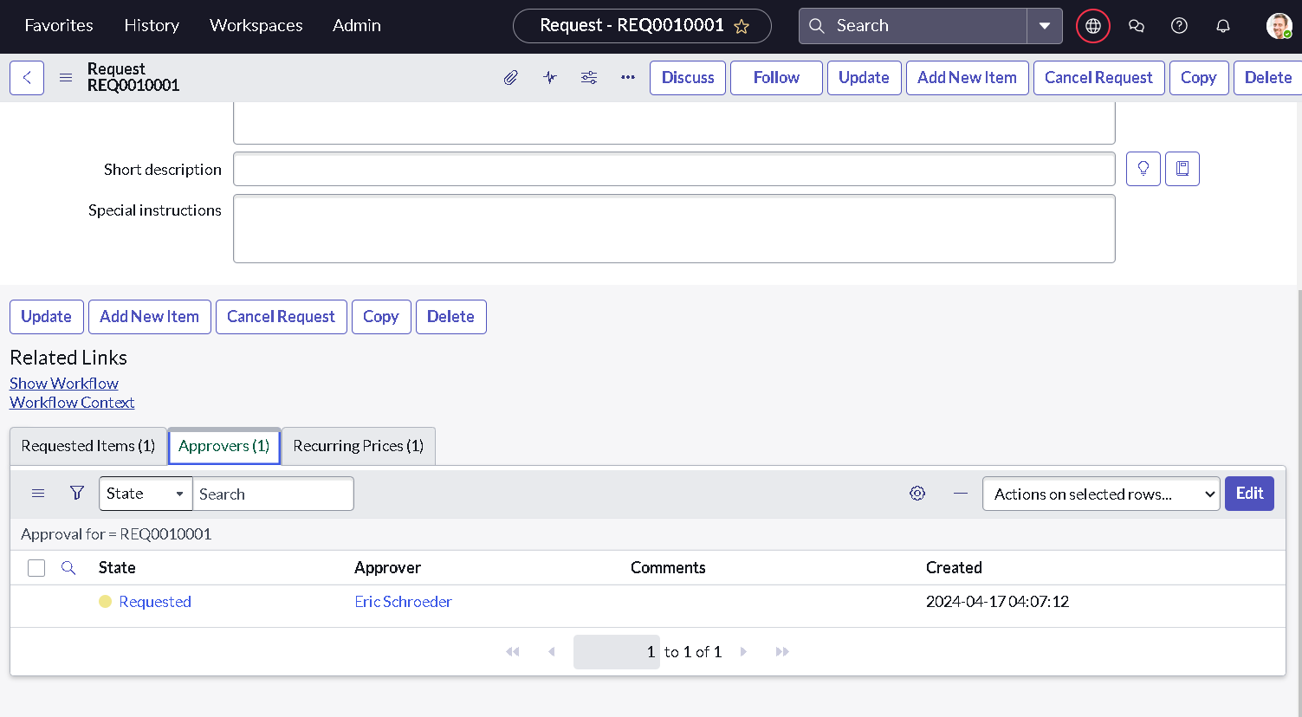
19.Select Approve.

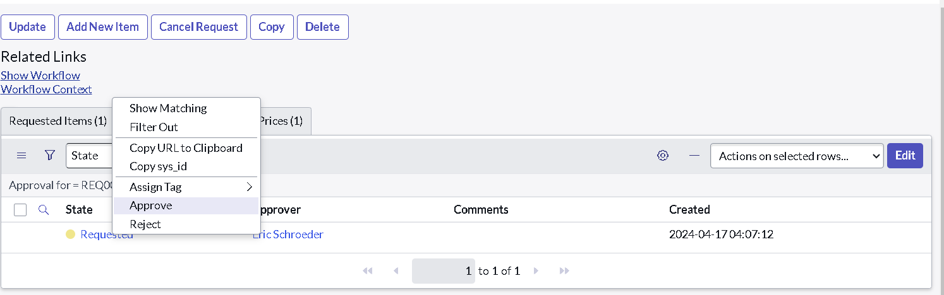

Step 4 – Open the Requested Item
20.Navigate to the Requested Item section.
21.Open the corresponding Requested Item record.
22.Review the details of the Standard Laptop request.
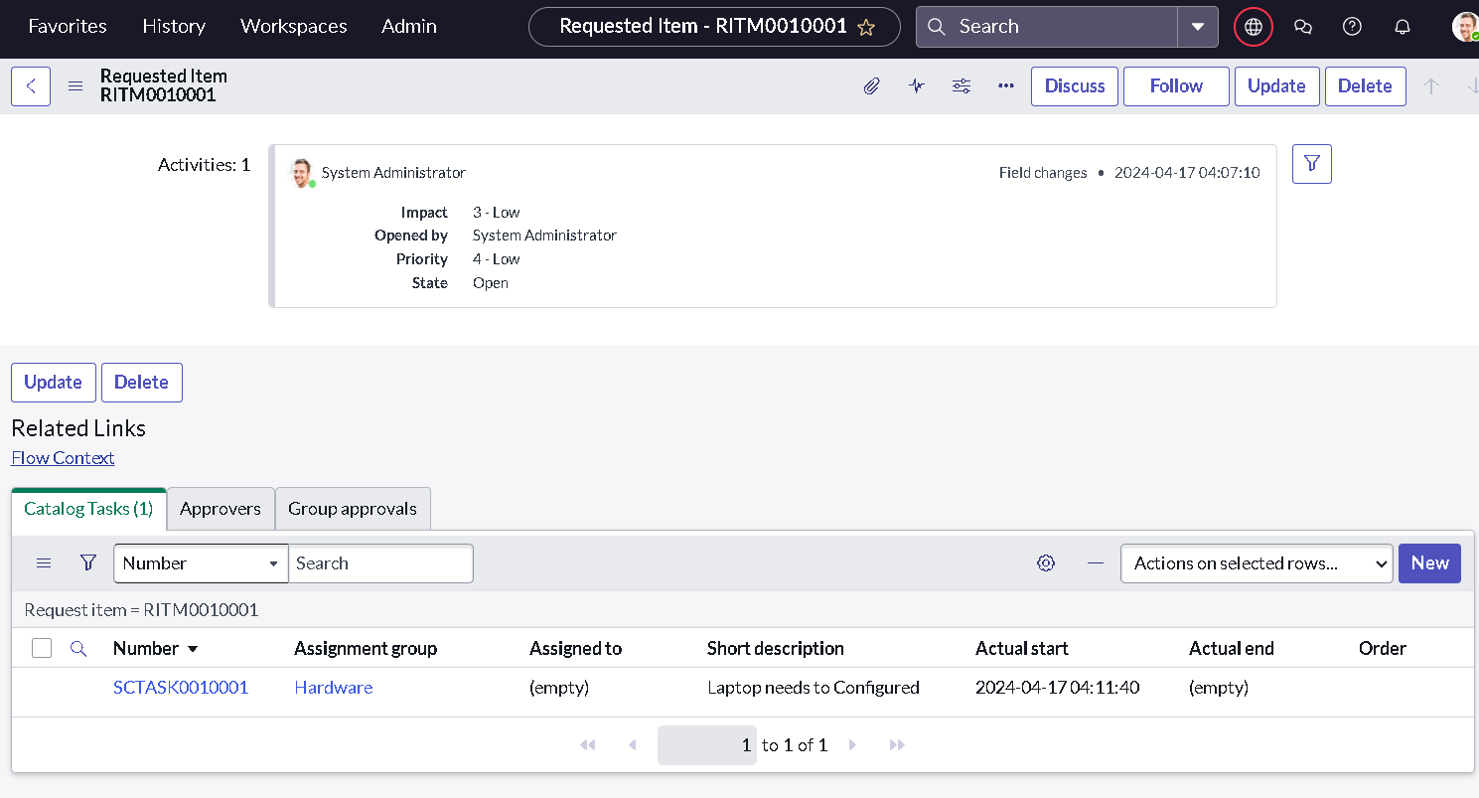

Step 6 – Verify the Catalog Task
23.In the Requested Item record, scroll down to the Catalog Tasks section.
24.Open the Catalog Task record.
25.Verify the updated status of the Catalog Task.
26.Verify the Short Description.
27.Verify the Assignment Group.
The expected task details are:
Field | Expected Value
Short Description | Laptop needs to Configured
Assignment Group | Hardware
Approval | Approved

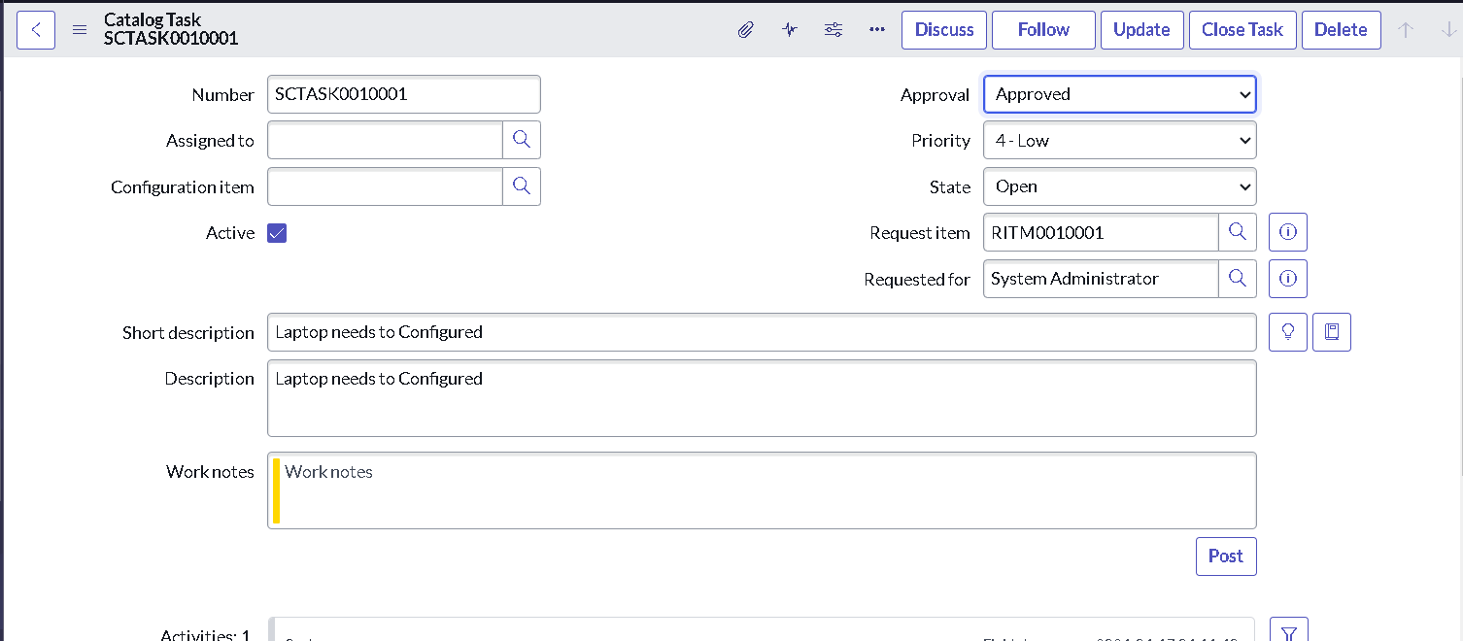
Task 3 Outcome
The Standard Laptop request was successfully placed through the Service Catalog and approved.
The Requested Item record was generated, and the Standard laptop task Flow automatically created the corresponding Catalog Task.
The Catalog Task contains the required short description and is assigned to the Hardware assignment group for laptop configuration.
This confirms that the Service Catalog request, approval process, Flow Designer automation, and Catalog Task creation are working together as intended.

5. END-TO-END WORKFLOW
The complete Standard Laptop procurement process follows the sequence below:
Standard Laptop Catalog Item
↓
User Places Order
↓
Request Created
↓
Request Approval
↓
Requested Item Generated
↓
Standard laptop task Flow Triggered
↓
Catalog Task Created
↓
Task Assigned to Hardware Team
↓
Laptop Configuration

Conclusion :
By automating the standard laptop procurement process with ServiceNow's Flow Designer, the project effectively addresses inefficiencies and reduces manual overhead. This streamlined workflow ensures timely configuration of laptops, minimizes user wait times, and enhances overall productivity within the IT department. The implementation of this automated solution not only optimizes resource allocation but also significantly improves the user experience by providing a seamless and efficient procurement process.

